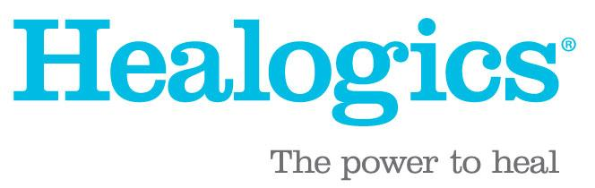
FOR IMMEDIATE RELEASE Contact: Name
Email
Phone Number

WOUND CARE CENTER NAME AIMS TO EDUCATE THE COMMUNITY DURING
WOUND CARE AWARENESS MONTH
CITY, STATE (DATE) – The Wound Care Center® at [Insert Hospital Name], a member of the Healogics network, is helping raise awareness of the risks of chronic wounds during the ninth annual Wound Care Awareness Week, June 6-10.
The nation’s leading provider of advanced wound care, Healogics®, established Wound Care Awareness Month in 2014 to bring attention to the growing need for wound care and nearly 7 million Americans currently living with chronic wounds. Program directors across the nation are dedicating the entire week to educating physicians, patients and the general public about the prevalence of chronic wounds and the advanced wound care solutions that are available. [Wound Care Center/Hospital Name] offers several advanced therapies to patients suffering from chronic wounds.
The incidence of chronic wounds is rising due to our aging population and increasing rates of disease. Various conditions like diabetes, peripheral artery disease (PAD), cardiovascular disease and chronic obstructive pulmonary disease (COPD) increase the likelihood of a person having or developing a chronic wound. A breakdown of wound types, by prevalence, for those living with chronic wounds include:
- Pressure Ulcers (43%)
- Diabetic Foot Ulcers (31%)
- Venous Stasis Ulcers (12%)
- Surgical Wounds or Trauma (8%)
- Arterial Ulcers (6%)
If left untreated, chronic wounds can lead to diminished quality of life and possibly amputation of the affected limb.
The effects of the COVID-19 pandemic have only made matters worse, as many suffering from chronic wounds have not sought needed care during the past two years. The result has been a steep rise in amputations, according to a study from the American Diabetes Association.
With this in mind, now is the time for those suffering from chronic wounds to seek advanced wound care available at Wound Care Center Name.
[Insert quote from Medical Director]
Visit www.woundcareawareness.com to learn more about Wound Care Awareness Week and hear from patients about how wound healing changed their lives. To schedule an appointment, please call [Phone Number] or visit [Website].
###
About [Wound Care Center Name]

About Healogics
Headquartered in Jacksonville, Fla., Healogics is the nation’s wound healing expert. Last year over 300,000 patients received advanced wound care through a network of over 600 Wound Care Centers. Healogics also partners with over 300 skilled nursing facilities to care for patients with chronic wounds and provides inpatient consults at more than 60 partner hospitals. As the industry leader, Healogics has the largest repository of chronic wound-specific patient data in the country. The Healogics Wound Science Initiative offers peer-reviewed research and advanced analytics in the pursuit of not only better outcomes but a better way to provide care.

