I-Heal Access for Post-Acute Facility Users
I-Heal Website: iheal.healogics.com
- Post-Acute team processes will ensure access for appropriate staff - typically Administrator, DON, ADON, and Wound Nurse
    - Access can be added for others as needs arise
    - Access forms can be found on our website at www.healogics.com. Steps are as follows: click “Professionals” (top right corner); then click “Hospitals”; then scroll down to click on “Learn More” under Skilled Nursing Facility heading; the I-Heal access form can be found there
    - Access forms need to be sent to postacute@healogics.com for approval.
- If you forget your password or get locked out of your account, please call I-Heal HelpDesk at 866-412-3680, option 1.
    - All passwords expire after 30 days.
    - Account access will be suspended after 90 days of inactivity.
- As roles change or staff is terminated, notify the Post-Acute Care Team to remove access.

Printing Progress Notes from I-Heal for Your Medical Records
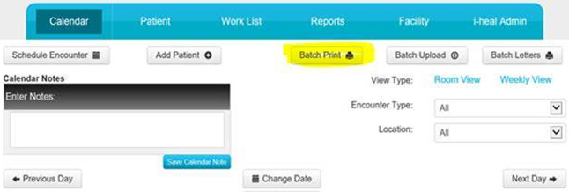
- Select “Batch Print” located on the Calendar screen.
- Pick the date of service. Under Individual Documents, choose Progress Notes, then submit. This will print each progress note submitted for every patients seen that day. Weekly printing recommended. To print a single patient - use Advanced Filters at the bottom, choose patient, submit.